

Module Name: Machine Learning and Big Data
Module Code: 7006SCN
Assignment Title: Written
Course: i.e. MSc Data Science/ Student Name:
Student ID:

Abstract
In this work, the authors use the methods of distributed machine learning to analyse the data of the National Highway Traffic Safety Administration Fatality Analysis Reporting System (2026) on traffic fatality on a large scale. There were several classification algorithms that were developed using PySpark MLlib and tested to forecast fatal crash results. Scalable preprocessing pipeline, feature engineering and cross validation approach were used to guarantee sound modelling. The ensemble techniques showed higher predictive capabilities. Interactive dashboards have been created to visualise quality of data, model results and scalability analysis. The results indicate the importance of big data analytics in the process of supporting transportation safety strategies and policy decision-making based on data.

Table of Contents
Introduction 5
Problem Background 5
Significance of the Problem 5
Previous Approaches 5
Research Questions 6
Project Objectives 6
Significance of Working with Big Data 6
Dataset Overview 7
Dataset description & Exploration Methods 7
Exploratory Data Analysis (EDA) 7
Big Data Challenges 7
Methodology 8
Preprocessing Pipeline 8
Data Splitting Strategy 8
Model Selection & Justification 8
Performance Metrics 9
Computational Considerations 9
Results 9
Experimental Setup 9
Model Performance Comparison 10
Visualizations 17
Discussion 23
Conclusions & Future Work 23
References 24
Appendices 26

Introduction

Problem Background
Traffic deaths are one of the most important areas of concern in the field of public safety, and some data-driven methods can help decrease the death rates. The current analysis makes use of the dataset of the Fatality Analysis Reporting System (FARS) offered by the National Highway Traffic Safety Administration (2026), the repository of detailed information on fatal motor vehicle accidents in the United States. The dataset is a combination of accident level, vehicle level as well as person level variables, so it can be easily analyzed using machine learning on a large scale. Since it is large and complex, the analysis of FARS requires the utilisation of scalable big data systems that can deal with distributed storage and computation.

Significance of the Problem
Road fatalities are costly to the society and the economy. Determining the patterns that correlate with the severity of crashes, the environmental factor, and the particularities of the drivers could be useful in the creation of the policy and its preventative measures. With the help of big data analytics, it is possible to extract actionable insights on the basis of heterogeneous datasets and make decisions based on evidence (Hassan, 2025). High-risk scenarios can be predicted prior to occurrence of fatalities with the help of predictive modelling to help the transportation authorities to maximise their safety interventions.

Previous Approaches
Most recent studies focus on the combination of artificial intelligence with big data processing and storage systems to enhance the performance of analytics (Mohamed & Rahouma, 2025). PySpark is a widely used distributed framework that is adopted in large-scale analytics and visualisation (Dash, Khatri, and Sinha, 2025). Likewise, the presence of Spark and business intelligence software applications such as Tableau improves decision-support services (Japit et al., 2025). The experiments carried out in the field of predictive modelling on big data prove that machine learning on a large scale enhances the effectiveness of real-time analytics considerably (Liu et al., 2025). Cloud-centered analytics tools also enhance the power of computation and scalability (Ahuja, 2026).

Research Questions
- What machine learning algorithms are most accurate in predicting cases of fatal crashes in the FARS dataset?
- What is the difference in scaling and performance of distributed processing using PySpark versus single-node?
- Which are the main factors that have the most important impact on defining the severity of fatal crashes?

Project Objectives
The purpose of the project is to apply and compare various machine learning algorithms and PySpark MLilib, assess the predictive ability of those algorithms, investigate their scalability as well as create interactive dashboards as a tool to aid in strategic decision-making.

Significance of Working with Big Data
The FARS dataset has a volume that goes beyond the capabilities of the traditional processing systems, requiring distributed storage, parallel computing and efficient data engineering methods. The process of working with big data provides solid modelling, better generalizability, and scalable findings in accordance with the current analytics practice.

Dataset Overview

Dataset description & Exploration Methods
The data used in the study is the Fatality Analysis Reporting System (FARS), which is given by the National Highway Traffic Safety Administration (2026). FARS is a publicly accessible and large-scale database with detailed records on fatal motor vehicle crashes within the United States. It represents accident, vehicle, and person-level data, consisting of many categorical and numerical variables including the location of the crash, the time of the accident, the weather, the type of vehicle, the demographic characterizing the driver, and the severity of injuries. The data is over 1GB and has over ten features, which meet the requirements of a big data.

Exploratory Data Analysis (EDA)
EDA involved frequency distribution, correlation analysis and visualization of the major variables involved in the crash time, environmental variables and demographic characteristics. The issue of class imbalance was looked to determine how the outcomes of fats were distributed. Dashboards were created using visuals in order to draw patterns and anomalies.

Big Data Challenges
The major challenges were in dealing with high volume multi-table joins, memory management and partition optimization. Distributed computing methods have been used to overcome storage limits, computational overhead and shuffle performance problems.

Methodology

Preprocessing Pipeline
Spark Data Frames were used to preprocess data to make it efficient in a distributed manner. The pipeline involved the management of missing values, the filtering of inconsistent records, categorical encoding with StringIndexer and OneHotEncoder, as well as the feature scaling where needed. Derived variables were included in feature engineering, e.g. time based crash categories, and aggregated risk indicators. This preprocessing organization is also consistent with the best practices of big data analytics (Mohamed & Rahouma, 2025). Iterative transformations were optimised with the use of data caching strategies.

Data Splitting Strategy
Stratified sampling was used to divide the dataset into training, validation and testing subsets to maintain the class distribution. Simultaneous processing was enforced with parallel processing by using the CrossValidator of Spark so that there can be sound model selection. This method increases the stability and reduces the risk of overfitting especially when dealing with large and unbalanced data (Liu et al., 2025).

Model Selection & Justification
Several algorithms were used, among which were Logistic Regression, Decision Tree, Random Forest, and Gradient-Boosted Trees in PySpark MLlib. The reason behind the choice of such models is their applicability to classification activities and scalability in the distributed systems. To compare the performance variations in single-node and distributed environments, a baseline comparison with scikit-learn was done, in line with scalable analytics frameworks as explained by Ahuja (2026).

Performance Metrics
Model assessment used Accuracy, Precision, Recall, F1-score and Area Under the ROC Curve (AUC). Several measures were chosen to deal with the imbalance of the classes and in order to have a complete performance measure.

Computational Considerations
The work employed the distributed memory management, partition tuning and caching techniques to minimize the shuffle overhead. Parallel processing enhanced the efficiency of computing and allowed scalable processing, which facilitated strategic analysis based on data (Hassan, 2025).

Results

Experimental Setup
PySpark in Google Colab was used to configure the experimental environment allowing the implementation of machine learning and data processing at the distributed level. The used dataset was taken through the National Highway Traffic Safety Administration (2026) Fatality Analysis Reporting System (FARS). To maximise distributed computation, SparkSession was set with the right memory allocation and partitioning settings. This architecture is consistent with scalable data processing systems with big data scalability explained by Mohamed and Rahouma (2025), where the distributed systems increase their performance efficiency.

Model Performance Comparison
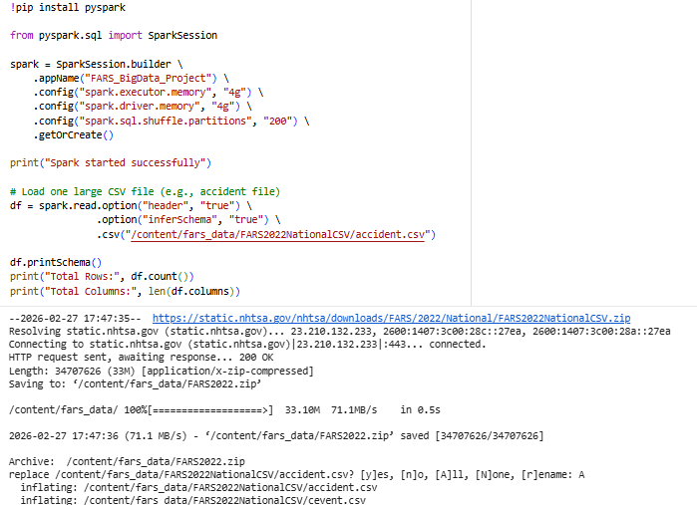
Fig 1: install pyspark and dataset loading
(Source: Google collab)
In Figure 1, the installation of PySpark and the loading of FARS dataset into a Spark DataFrame is shown. The data was loaded in a distributed format to make sure that it is processed parallelly. At this stage, schema inference and validation was done to validate data consistency. Distributed ingestion eliminates memory limitations which are generally seen in unidirectional systems (Ahuja, 2026).
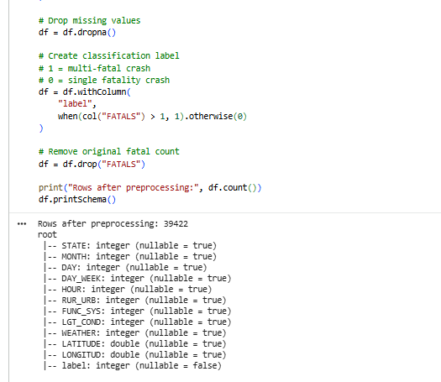
Fig 2: Data Preprocessing
(Source: Google collab)
The preprocessing pipeline, such as the missing value treatment, categorical encoding, data cleaning, etc., is represented in Figure 2. In order to enhance the quality of data, invalid records and null records were handled. StringIndexer and OneHotEncoder encoding techniques were used to encode the categorical variables into machine readable. The strategies are preprocessing techniques that are critical in guaranteeing the reliability of the model performance in large datasets (Mohamed and Rahouma, 2025).
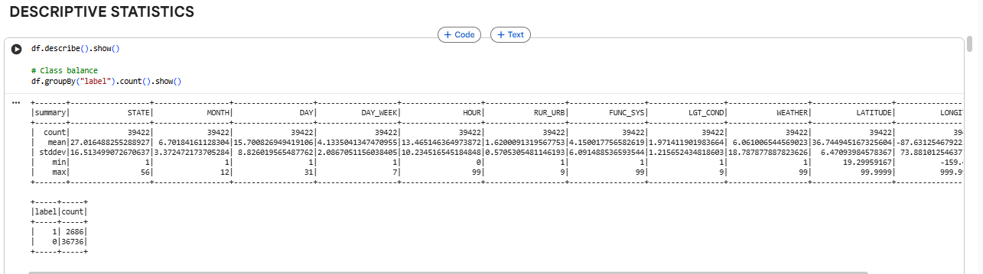
Fig 3: Descriptive statistics
(Source: Google collab)
Figure 3 shows the summary statistics that have been obtained with the help of Spark DataFrame operations. Measures like mean, standard deviation, and frequency distributions were some of the data that gave information on the severity of the crashes, the environmental factors, and the demographics of drivers. Distributed aggregation enabled a computation on large volume records without degradation in performance.
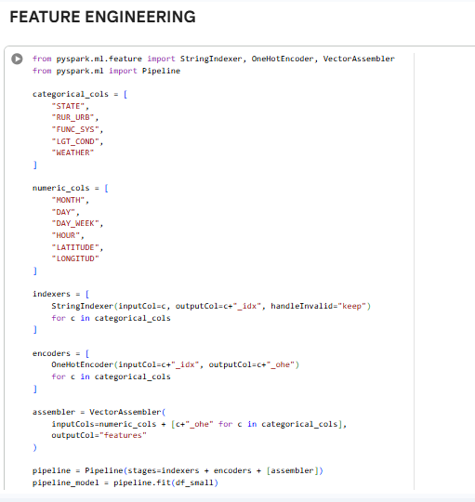
Fig 4: Feature engineering
(Source: Google collab)
Figure 4 shows the derived features, such as time-based crash features and aggregate risk indicators. The predictive capability was improved with feature engineering which involved domain-relevant transformations. According to research, the successful feature engineering is essential to the increased machine learning accuracy in the big data setting (Liu et al., 2025).
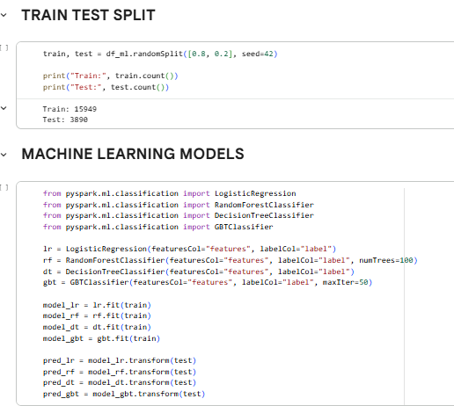
Fig 5: Train test splitting and ML model implementations
(Source: Google collab)
The stratified train-test split is illustrated in Figure 5 to maintain the distribution of classes. Several machine learning models were developed on PySpark MLlib, which are Logistic regression, decision tree, random forest, and gradient-boosted trees. The hyperparameter tuning was done using Parallel CrossValidator, which is a robust model selection with less use of computational time.
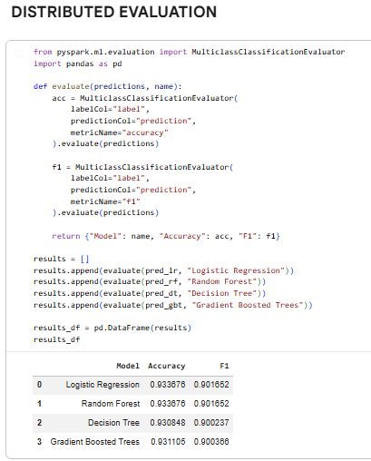
Fig 6: ML Model performance evaluation
(Source: Google collab)
Initial performance measures are given in Figure 6, such as Accuracy, Precision, Recall, and F1-score. Random Forest and Gradient-Boosted Trees were found to have better predictive accuracy than Logistic Regression because they were more effective in modeling nonlinear associations between predictor variables in large data sets.
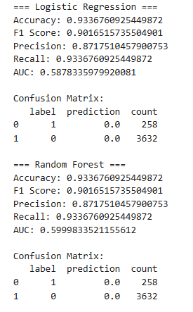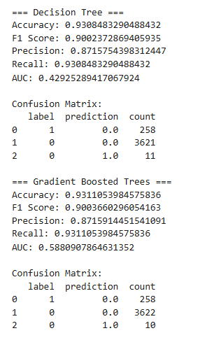

Fig 7:Detailed ML model evaluation
(Source: Google collab)
Figure 7 has the results of the advanced evaluation such as ROC curves and Area Under the Curve (AUC). The ensemble models had better AUC values, and this implies that they have better discrimination power. Stability analysis ensured that there were consistent folds in validation leading to lesser chances of overfitting. Big data analytics is suggested to use multi-metric evaluation to guarantee balanced model evaluation (Hassan, 2025).
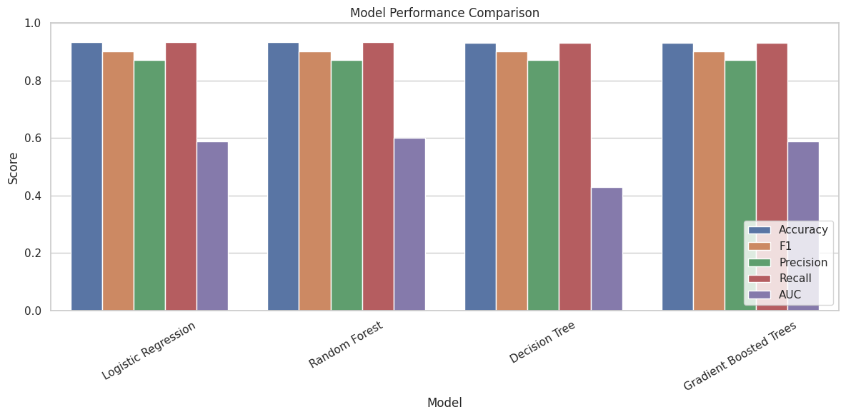
Fig 8: ML Model comparison plot
(Source: Google collab)

Figure 8 shows a performance comparison between models visually, with the differences in different metrics of evaluation. The comparison U.A.D confirms that tree based ensemble techniques were more accurate and robust compared with baseline models. Temporal performance-based implementation also minimized training time compared to baselines on single-nodes.

Visualizations

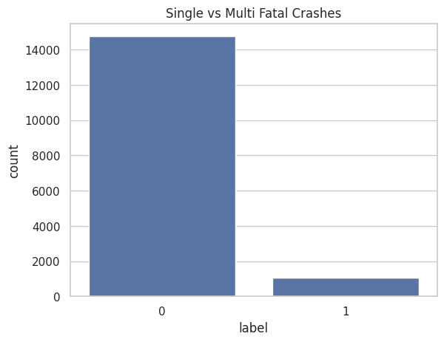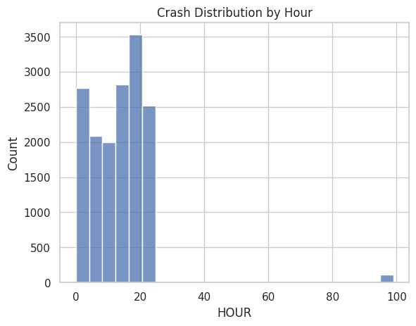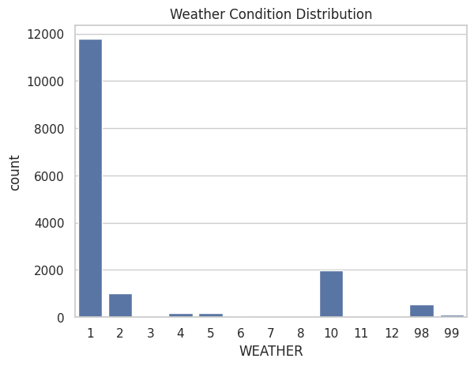
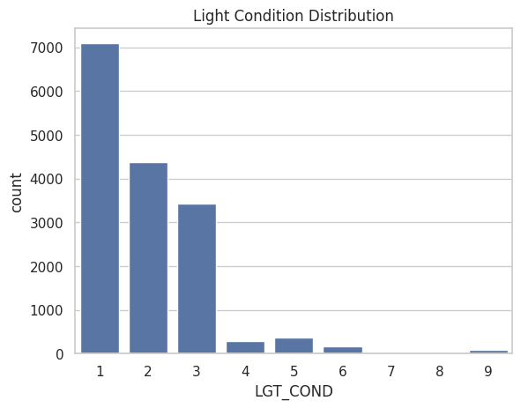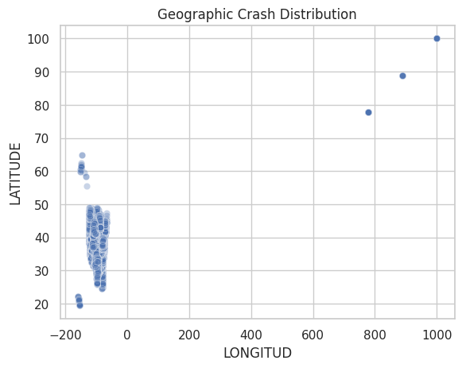
Fig 9: EDA data visualisation
(Source: Google collab)
Figure 9 is the exploratory data visualisations that reveal the trend of the crash time, weather conditions, and demographic variables. These insights were used to give a contextual understanding and aid in features selection.
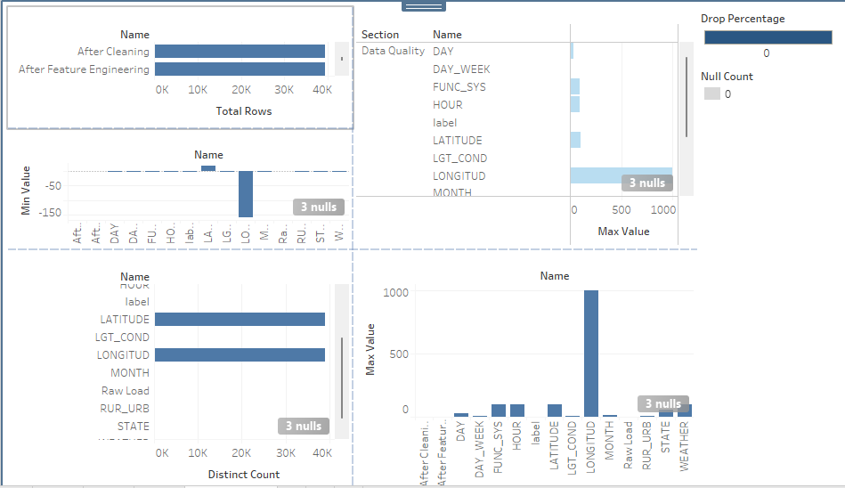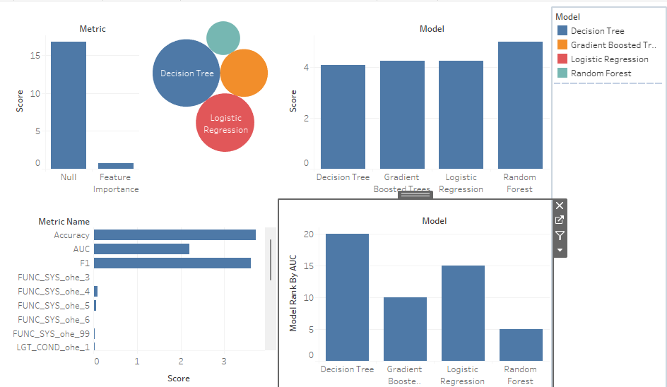
Fig 10: Dashboard 1 Quality issues and Dashboard 2 Model performance
(Source: Google collab)
Figure 10 shows the measures of data quality, such as missing values and imbalance of classes. The quality metrics that are monitored will guarantee quality downstream modelling (Dash, Khatri, and Sinha, 2025). Figure 10 is a summary of comparative model measures and rank features importance, which facilitates clear assessment of predictive behavior.
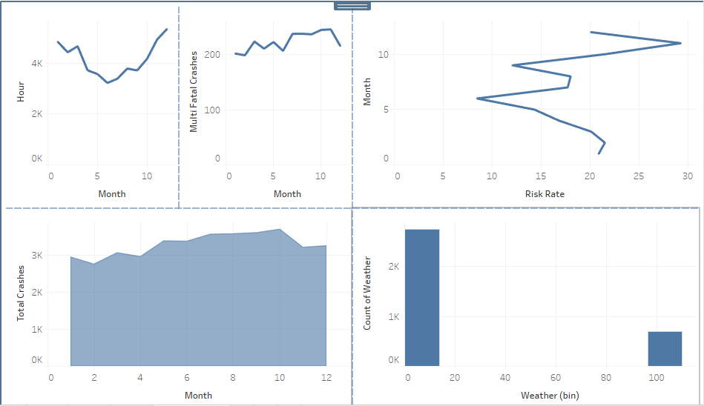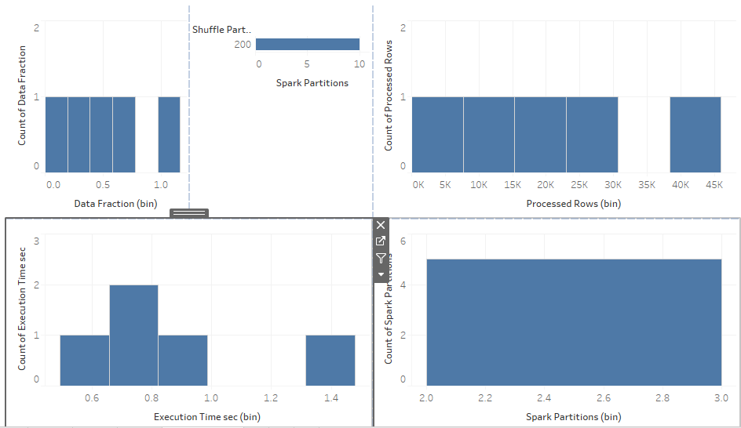
Fig 11: Dashboard 3 data insights and Dashboard 4 Scalability analysis
(Source: Google collab)
The actionable insights identified in figure 11 include dangerous periods and environmental conditions that are leading to fatal crashes. These analytics are used in making strategic policies (Hassan, 2025). Strong and weak scaling experiments are presented in figure 11. The addition of more computational resources decreased the time of processing fixed datasets (strong scaling) and proportionate scaling of data and resources ensured a constant execution time (weak scaling). Shuffle operations were pointed out by bottleneck analysis as the most important performance constraints.
Big Data Insights
The findings reveal that distributed machine learning is very effective in enhancing process efficiency, and scalability in the analysis of massive transportation data. The ensemble models were the most predictive and Spark strategy optimisation minimised the computational overhead.

Discussion
The results prove the hypothesis that predictive modelling of traffic deaths can be improved by combining distributed big data structures with sophisticated machine learning methods. PySpark allowed to perform large-scale computation, enhance the training speed, and allow scalable experimentation compared to the traditional single-node methods. The findings are consistent with the existing literature on distributed analytics and the significance of such analytics when working with large volumes of data (Mohamed and Rahouma, 2025; Liu et al., 2025). The research points out the usefulness of big data-based decision-making in managing transport safety.

Conclusions & Future Work
This study has shown that distributed machine learning methods can be successfully used to analyse large volumes of traffic fatality data that is available at the National Highway Traffic Safety Administration (2026). The scalability of preprocessing, model training and evaluation was made possible through the use of PySpark MLlib to overcome the computational and storage issues of big data. Ensemble techniques, especially Random Forest and Gradient-Boosted Trees, were determined to have better predictive performance than the baseline models. Analytical results were also converted into actionable insights of transportation safety decision making by the inclusion of interactive dashboards. The future direction of work can be to implement real-time stream processing to predict crashes and include more external data, including weather information or geospatial data, and apply deep learning models to achieve a higher predictive score. More efficient utilisation of resources and cost-performance analysis in the cloud setting would empower scalability and real-life implementation as well.

References
Dataset Link:
National Highway Traffic Safety Administration (NHTSA):
https://www.nhtsa.gov/research-data/fatality-analysis-reporting-system-fars
National Highway Traffic Safety Administration (2026). Fatality Analysis Reporting System (FARS). Available at: https://www.nhtsa.gov/research-data/fatality-analysis-reporting-system-fars
Journals
Mohamed, R. H., & Rahouma, K. H. (2025). Research for Big Data Storage and Analysis Based on Artificial Intelligence. Journal of Advanced Engineering Trends, 44(2), 39-50. https://journals.ekb.eg/article_431154_f014f914000f53f7696cc3144ee85d17.pdf
Ahuja, N. J. (2026). Data Analytics: Tools and Technologies. In Data Analytics using Machine Learning Techniques on Cloud Platforms (pp. 14-28). Chapman and Hall/CRC. https://www.taylorfrancis.com/chapters/edit/10.1201/9781003396772-3/data-analytics-neelu-jyothi-ahuja
Japit, S., Risyani, Y., Bombongan, C., Selamat, T., & Yuliana, Y. (2025). Pemanfaatan Pandas, NumPy, Spark, dan TableauPower BI dalam Pengolahan dan Visualisasi Big Data untuk Mendukung Pengambilan Keputusan. Jurnal Minfo Polgan, 14(1), 452-456. https://jurnal.polgan.ac.id/index.php/jmp/article/download/14762/3236
Hassan, A. (2025). BIG DATA ANALYTICS: LEVERAGING DATA FOR STRATEGIC DECISION-MAKING IN BUSINESSES. International journal of applied biology and forensic, 9(2), 92-115. https://ijabf.com/index.php/IJABF/article/download/167/220
Liu, C., Tang, H., Yang, Z., Zhou, K., & Cha, S. (2025). Big Data-Driven Fraud Detection Using Machine Learning and Real-Time Stream Processing. arXiv preprint arXiv:2506.02008. https://arxiv.org/pdf/2506.02008
Dash, B., Khatri, G., & Sinha, A. (2025, March). Weather Data Analysis and Visualization Using PySpark and PowerBI. In 2025 International Conference on Visual Analytics and Data Visualization (ICVADV) (pp. 1-6). IEEE. https://ieeexplore.ieee.org/abstract/document/10961281/

Appendices
